Philhealth
https://www.philhealth.gov.ph/services/
CONTRIBUTION
eprs
log-in
Payment Management
Employee's Management (update list of employee's)
Payment Management
1. Payment Posting

1. Print (Optional)
2. Generate SPA - Submit
3. Printing of SPA
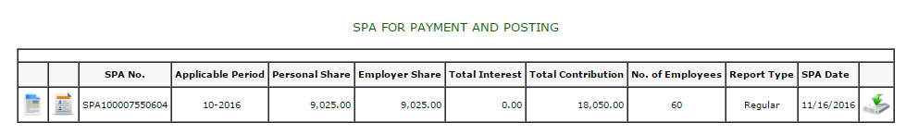

4. Payment (Manually) – with SPA
5. Posting of contribution

Pag Ibig

Microsoft excel – required

- Create dat file using Pagibig File Generator - for monthly contribution
- Create dat file using STL_File generator – for monthly loan payment
- Send dat file to accounting personnel
- Uploading of payment
- Posting of payment - Automatic
SSS
- Create dat file using SSS EELST-MCL File Writer - for monthly contribution
- Create dat file using LCL File Creator – for monthly loan payment
- Send dat file to accounting personnel
- Uploading of payment
- Posting of payment – Automatic
PHIC
- Create dat file using PhilHealthRemittance Writer
- Send dat file to accounting personnel
- Uploading of payment
- Posting of payment - Automatic

With BPI Access
 | SSS | PHIC | PAG IBIG
1Rotary | Y |  | Y
Rotek | Y |  | Y
North Rotek |  | Y | Y
Reliance | Y | Y | Y
Panay | Y | Y | Y

